Student Performance Prediction System

Team Id: PY-GT-69

Name : Subhansh Singh Rawat(Team Leader)
Class Roll Number:69
University Roll Number : 2028867
Section and Group: G(G2)

Name : Nidhyati Bisht
Class Roll Number:51
University Roll Number : 2028782
Section and Group: G(G2)

Name : Vishwas Sahu
Class Roll Number:75
University Roll Number : 2028909
Section and Group: G(G2)

- Problem Description 3
- Architecture 4
- Models model 5
- Evaluation metrics used 6
- Preliminary Results and Visualizations 7
- References 8

1.Problem Description

Fraudulent Credit Card Transaction Detection Using Machine Learning
Credit card fraud has become one of the major challenges in the digital banking and e-commerce industry. Fraudulent transactions not only cause financial losses to banks and customers but also reduce trust in online payment systems. Since millions of transactions occur daily, manually identifying fraudulent activities is difficult, time-consuming, and inefficient. Therefore, an intelligent automated fraud detection system is required to accurately identify suspicious transactions in real time.
The objective of this project is to design and develop an end-to-end machine learning classification system capable of detecting fraudulent credit card transactions using transaction-level financial data. The system will use historical transaction records containing both legitimate and fraudulent transactions to train predictive models.
The project begins with selecting a suitable fraud detection dataset and performing comprehensive data preprocessing. This includes handling missing values, removing duplicate entries, scaling or normalizing numerical features, and transforming the dataset for better consistency and model performance. Since fraud datasets are highly imbalanced (fraudulent transactions are very rare compared to legitimate ones), appropriate imbalance-handling techniques such as SMOTE, undersampling, or oversampling must be applied.
Feature selection techniques will be used to identify the most relevant transaction attributes that contribute to fraud detection, improving both model interpretability and prediction accuracy. The system will then implement and compare multiple machine learning classification algorithms including Logistic Regression, K-Nearest Neighbours (KNN), and Support Vector Machine (SVM).
The performance of the trained models will be evaluated using classification metrics such as Accuracy, Precision, Recall, F1-Score, Confusion Matrix, ROC Curve, and AUC Score. Special emphasis should be placed on maximizing recall and minimizing false negatives, as undetected fraud can lead to serious financial risks.
The final output of the system should classify each transaction as:
- 0 → Legitimate Transaction
- 1 → Fraudulent Transaction
This project demonstrates a complete machine learning pipeline from raw financial transaction data to a fully evaluated fraud detection model, highlighting best practices in preprocessing, imbalance handling, classification, and performance evaluation.

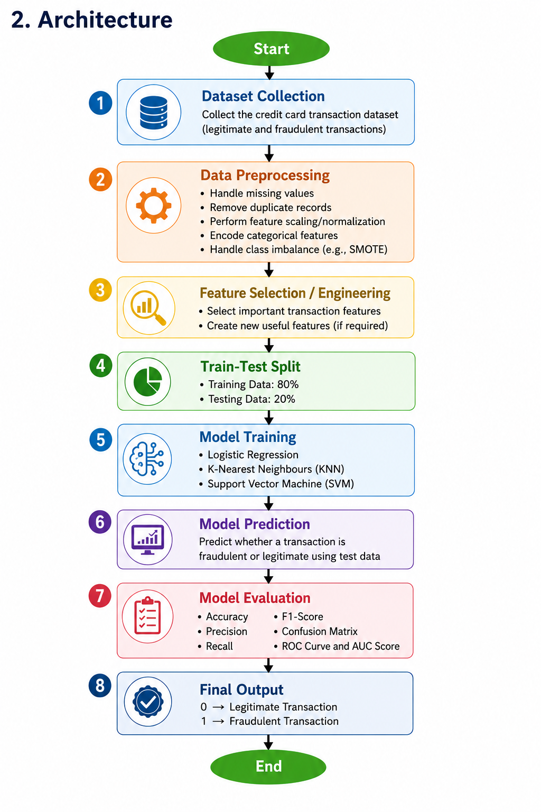
Fig.1 Sample flow diagram.

- Models Used(Applied/ Planned) Give a brief introduction of the models used

In this project, three supervised machine learning classification algorithms are implemented and compared to detect fraudulent credit card transactions.
- Logistic Regression:
A statistical classification algorithm used to predict whether a transaction is fraudulent or legitimate. It is simple, efficient, and works well for binary classification problems.
- K-Nearest Neighbours (KNN):
A distance-based classification algorithm that classifies a transaction based on the majority class among its nearest neighboring data points.
- Support Vector Machine (SVM):
A powerful classification algorithm that finds the optimal hyperplane to separate fraudulent and legitimate transactions with maximum margin.
All models are trained using the same preprocessed dataset and evaluated using identical performance metrics for fair comparison

- Evaluation metrics used

The performance of the models is evaluated using the following metrics:
- Accuracy:
Measures the proportion of correctly classified transactions.
$$Accuracy=\frac{TP+TN}{TP+TN+FP+FN}$$
- Precision:
Measures how many predicted fraudulent transactions are actually frauds.
$$Precision=\frac{TP}{TP+FP}$$
- Recall (Sensitivity):
Measures how many actual fraudulent transactions are correctly identified.
$$Recall=\frac{TP}{TP+FN}$$
- F1-Score:
Harmonic mean of Precision and Recall.
$$F1=\frac{2×Precision×Recall}{Precision+Recall}$$
- Confusion Matrix:
Displays True Positives (TP), True Negatives (TN), False Positives (FP), and False Negatives (FN).
- ROC Curve and AUC Score:
ROC curve shows the relationship between True Positive Rate and False Positive Rate.
AUC score measures the overall classification performance of the model.

5. Preliminary Results and Visualizations

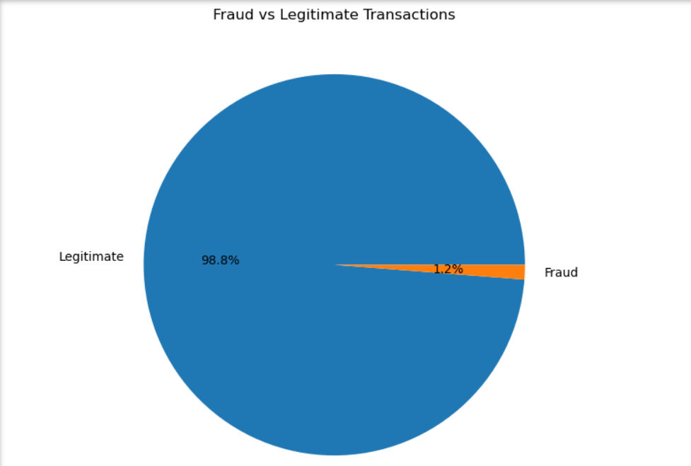

Fig.2 pie chart showing the distribution of fraudulent and legitimate transactions in the dataset.

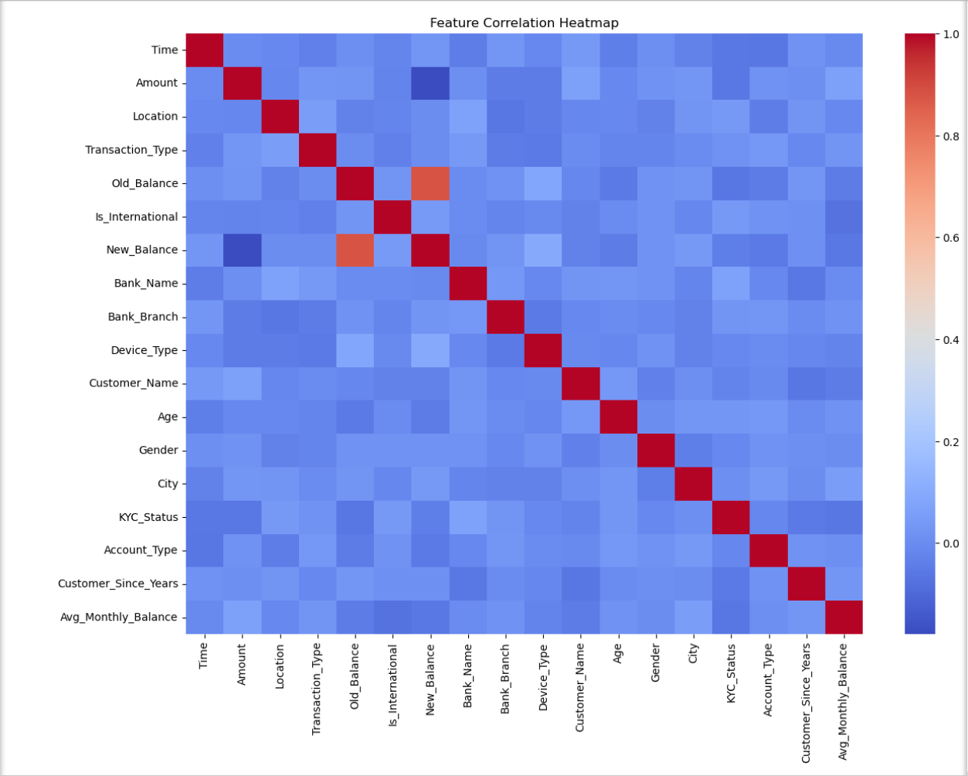

Fig.3 Heatmap showing correlation between different features in the credit card transaction dataset used for fraud detection.

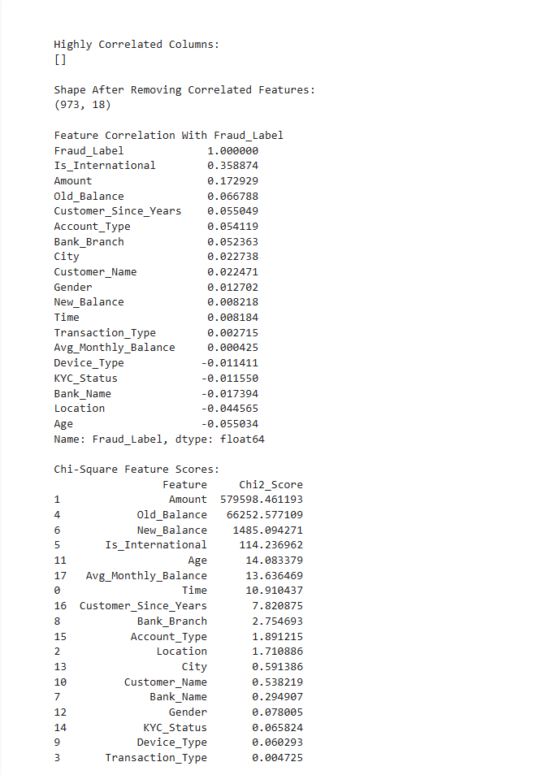

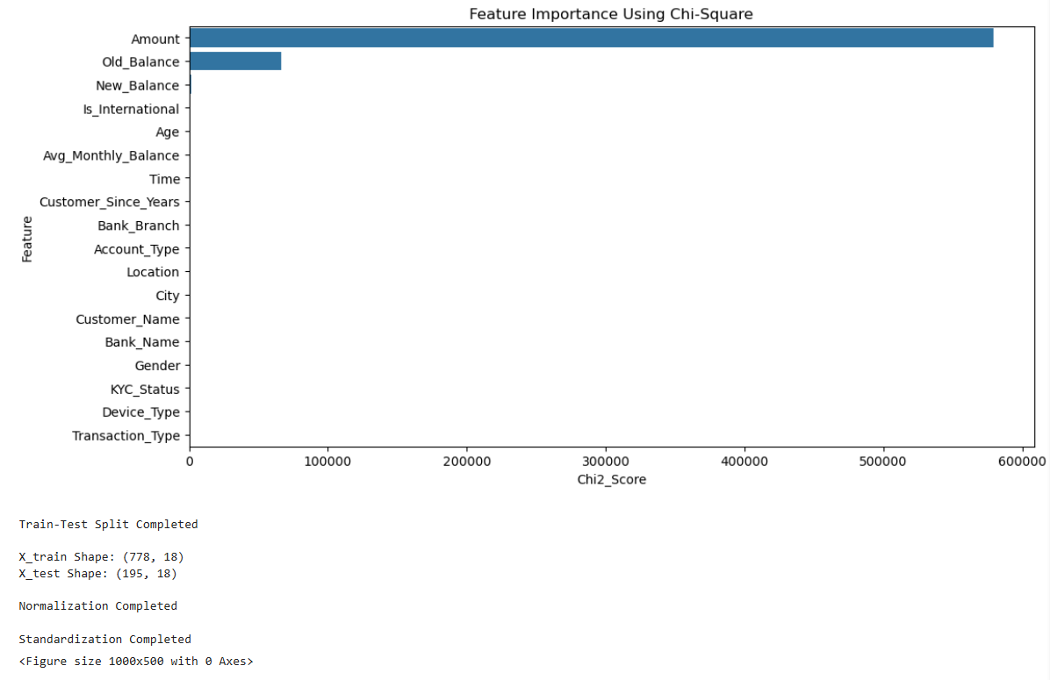

Fig.4-

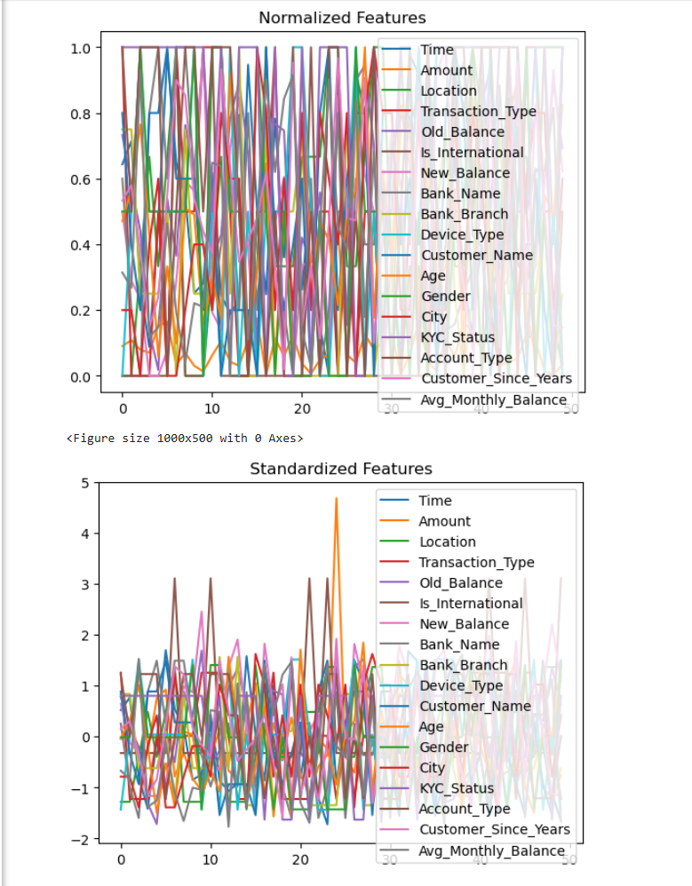

Fig.5- the comparison between Normalized Features and Standardized Features used during the preprocessing stage of the fraud detection dataset.

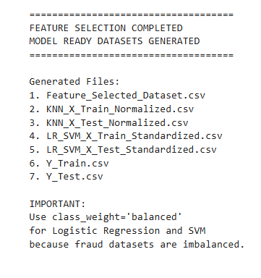
6. References:
• Bhattacharyya, S., Jha, S., Tharakunnel, K., & Westland, J. C. (2011). Data mining for credit card fraud detection. Decision Support Systems.
• Chawla, N. V., Bowyer, K. W., Hall, L. O., & Kegelmeyer, W. P. (2002). SMOTE: Synthetic Minority Over-sampling Technique. Journal of Artificial Intelligence Research.
• James, G., Witten, D., Hastie, T., & Tibshirani, R. (2021). An Introduction to Statistical Learning. Springer.
• Tan, P. N., Steinbach, M., & Kumar, V. (2019). Introduction to Data Mining. Pearson.
• Dal Pozzolo, A., Caelen, O., Johnson, R. A., & Bontempi, G. (2015). Calibrating probability with undersampling for unbalanced classification. IEEE Symposium Series on Computational Intelligence.

